Brianna Hernandez
Miguel Perez
Isaac Magallanes
Hist 87 MW 9:35
Exam 2

Multiple Choice

1. During the Cold War, the two Superpowers were:
A. China and Japan
-B. Soviet Union and United States
C. Korea and Vietnam
D. Britain and Germany

2. The Soviet Union’s goal during the Cold War was to:
-A. Spread Communism
B. Make friends with the United States
C. Contain Communism
D. Take over the world
3. When did the US join the WWII?
A. 1780
B. 1870
C. 1920
-D. 1941

4. How did the US stay out of the war?
A. Nationalism
-B. Isolationism
C. Fascism
D. Buddhism

5. What country remained unaffected by the great depression?
-A. Soviet Union
B. England
C. France
D. Italy

MATCHING

6. The Marshal Plan
7. The Truman Doctrine

A. an assistance program where the United States would provide food, machinery and other
Supplies to rebuild Western Europe. Was approved after communist powers seized
Czechoslovakia.

b. Truman's support for countries that rejected communism.
Which country did the following images come from?
A Germany B.US C. England D. Soviet Union
8.

9. 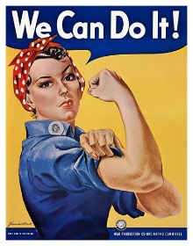

Map
Place the question number on the appropriate area
10. Austria Hungary before WWI
11. Germany after WWI
12. Czechoslovakia
True/False
A. True B. False
13. Henry Morgan was known for being a pirate
14. Hitler was an elected official in Germany
Short Answer
15. Name one of the Theaters of World War II
16. What was the name of Hitler’s book?
17. What event caused Britain and France to declare war on Germany and officially start WWII?
18. What were some factors which helped Adolf Hitler rise to power in Germany?
19. Name one of the countries affected by proxy wars as a result of the Cold War
Essay
Give a detailed description of what life would have been like during the Great Depression. Use at least two examples of different countries.

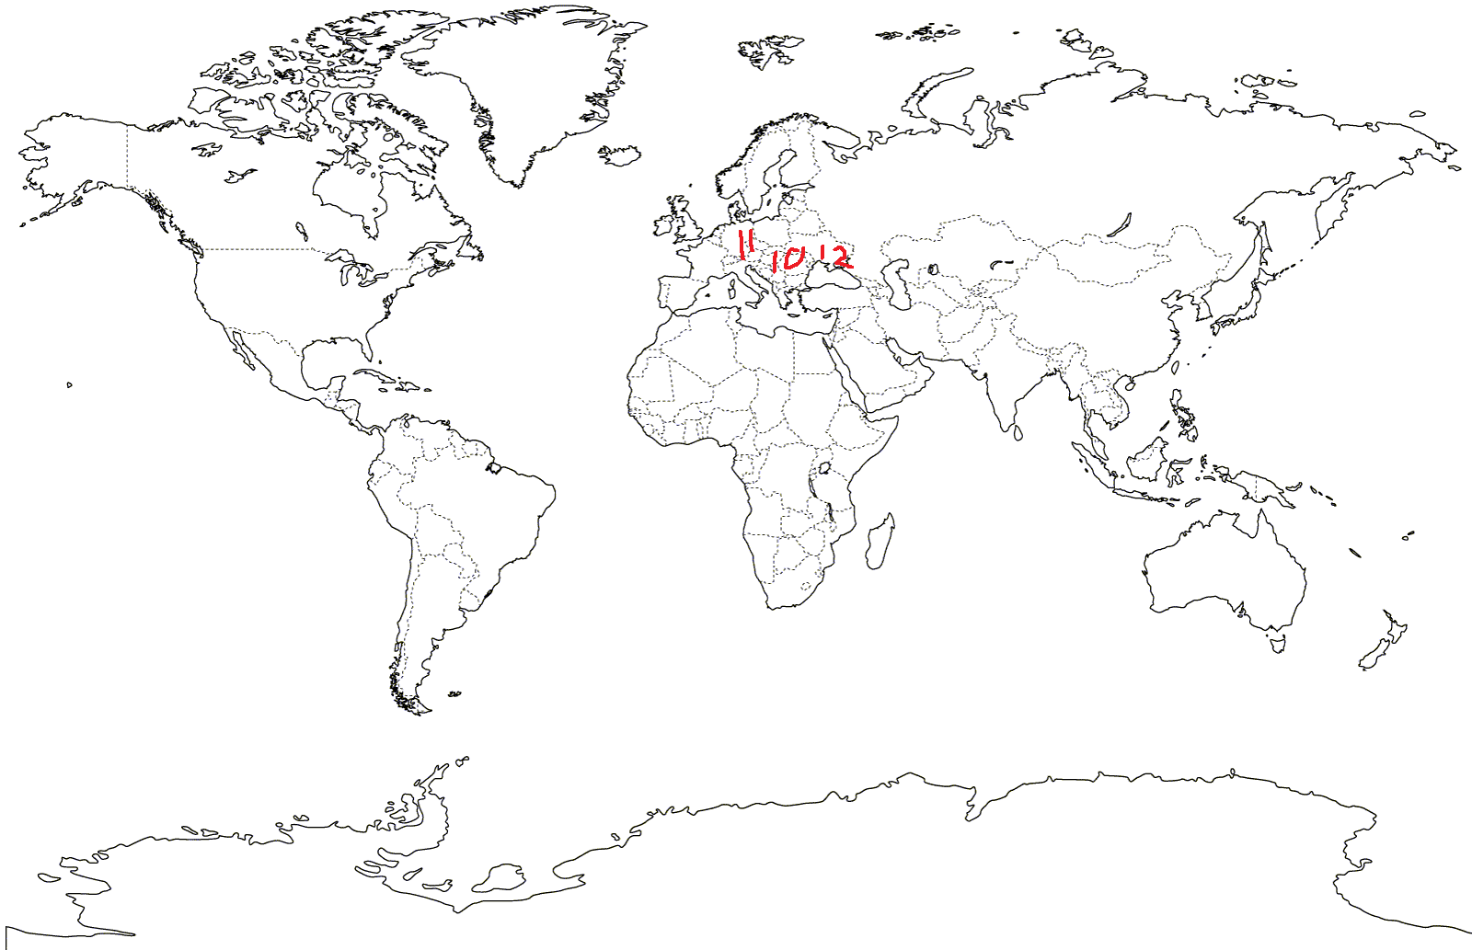

Key
- B
- A
- D
- B
- A
- A
- B
- A
- B
- On map
- On map
- On map
- A
- A
- Could be European, Mediterranean, pacific Asian,
- Mein Kampf
- The invasion of Poland
- The economic ramifications of WWI, the spirit of the German people after WWI
- Vietnam or North/South Korea
- Between 4-5 paragraphs escribing life during the great depression, at least two countries affected by it

