Multiple Choice
- What was the Coxey’s Army?
      - In Colorado and Idaho there was great success, winning support of industrial workers and miners.
      - An Ohio businessman led a large group of jobless men to march to Washington to insist for economic relief. ———— Answer: B
      - An 8-1 decision, arguing facilities that were segregated but did not discriminate as long ad they were “separate but equal.”
      - None of the above.
- All of the following are causes of WWII except:
      - Unresolved conflicts in WWI
      - The Japanese’ territorial expansion
      - Pearl Harbor ———— Answer: C
      - Economic collapse from WWI
- All are true about Malcolm X except the following:
      - Supported the March on Washington ———— Answer: E
      - Influenced by his following of Islam
      - Was pro-violence in defense
      - Former convict
- The Vietnam war was involved with…
      - Segregation within American soldiers
      - 50,000 Americans & Millions of Vietnamese dead
      - Communism between the North and South of Vietnam
      - Anti-war protests in the United States
      - All of the Above ———— Answer: E
- Being a Freedom Rider meant that one was:
      - Not in favor of sitting in the back of the bus
      - Only African-American
      - From the South
      - Targeted by white supremacist ———— Answer: D

Short Response
- What was the Lend - Lease Act? What countries were involved and which ones where they all against during this time?
    - Countries involved were China, Britain, and the Soviet Union to fight off Germany and Japan.
    - This act was passed by the congress to authorize military aid but only if the countries that participated in this would agree to pay it back in someway.
- Name three or more factors to the Economic expansion of the US after WW2
    - The Population (Rise of the Baby Boomers)
    - Suburban Lifestyle
    - Consumer Growth
    - TV culture
    - Interstate Highway Act
    - Low Unemployment

True or False
- The Navajo is one of the rarest language and was used during WWII to confuse the Japanese when they were trying to tune into their communication system.
  - True
- Boat people were european refugees who fled to the United States.
  - False (Vietnamese Refugees)
- A beatnik is defined as young, artistic, and a non-conformist.
  - True
- In the reading “A Different Mirror” the Japanese Americans were the only ones to face hate by the U.S. society.
  - False (American Americans also faced hate crimes)
- Based on the reading of “A Different Mirror” the bombing of Hiroshima was also known as Holocaust.
  - True

Essay Question
- Music was a great influence in history, in what ways did music affect U.S. society today and back then?
    - “Rock N’ Roll” ——> allowing young individuals to rebel, also lead to opening diversity a bit more
    - Beat ——> nonconformist, sexual experimentation
    - Woodstock ——> contraception pill, drug (acid), kinda the first raves
    - Salsa ——> mixed with Jazz, American made music
- A constant saying discussed in class is that “History Repeats itself”. What events learned in class do you see related to events of our current time and what do you think are the reasons to why they repeat?
    - “Rock N’ Roll” ——> allowing young individuals to rebel, also lead to opening diversity a bit more
    - Beat ——> nonconformist, sexual experimentation
    - Woodstock ——> contraception pill, drug (acid), kinda the first raves
    - Salsa ——> mixed with Jazz, American made music

Questions Based On Images
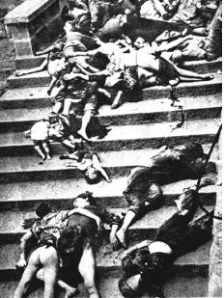
- Based on the image below, name the following event, and list a couple of things that were discussed in class about this event.
- Event: “Rape of Nanking”

- its the forgotten genocide
- the bayonet was the weapon used during this event
- Japanese used diabolical games when they killed
- group rape was also used
- many individuals were buried alive
- some individuals were burned alive
- many were beheaded
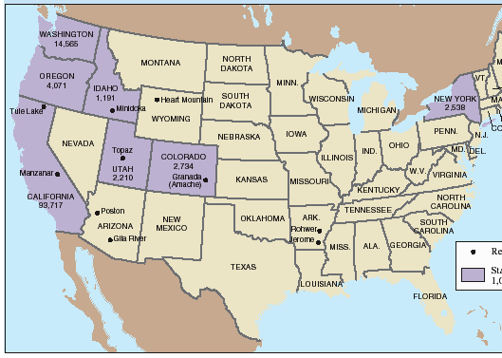
- The map below shows specific places in the following states during the 1940’s. What what happening during the U.S during this time and why are these states significant to the time era?
- U.S. is involved in WWII after the devastating event of Pear Harbor.
- These states represent internment camps were Japanese citizens in America were forced to leave their belonging and sent to these places.
- This event was done in the name of National Security in the U.S.
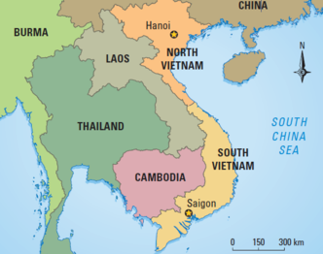
- The image below is a map of the South Asian War, where were most of the U.S. military bases located?
    - South Vietnam
- Based on the same map below, where were the remaining military bases located?
    - Thailand
- Based on the same map where did the U.S. military invade?
    - Cambodia

- Name 3 states on the map below that have a range of 1 million or more immigrants:
    - California
    - Texas
    - Florida

