Quiz

Multiple choice
1. What did the Hart-Celler Act do?
a) Eliminated the national origins quota system for immigration established by laws in 1921 and 1924.
b) Limited U.S. immigration to 3 percent of each foreign-born nationality in the 1910 census.
c) Outlawed discrimination in public accommodations and employment.
d) Halted Chinese immigration to the United States.

2. During the 1960’s when hippies were becoming more popular, which of these did they typically not do?
a) Used birth control
b) Drank alcohol
c) Used LSD
d) Used heroin

3. What is not true about the Holocaust?
a) There was systematic purging.
b) It was the Nazis “final” solution.
c) The U.S. did not take in any Jewish refugees.
d) The death camps killed 6 million Jewish people.

4. Which act authorized military aid so long as countries promised somehow to return it all after the war?
a) Taft-Hartley Act
b) Lend-Lease Act
c) National Defense Education Act
d) McCarran-Walter Act

5. Who went to the University of Alabama but was stopped by the Governor because he did not want an African-American in that school?
a) James Meredith
b) Jackie Robinson
c) Vivian Jones
d) Rodney King

Match the number with the correct answer
___6. Zoot suit riots
___7. Tet offensive
___8. My Lai Massacre
___9. Culture wars

a) American troops killed some 350 South Vietnamese civilians.
b) Sailors and policemen attacked Mexican-American youths wearing flamboyant clothing on the streets of Los Angeles.
c) Battles over moral values that raged throughout the 1990’s.
d) Surprise attack by the Viet Cong and North Vietnamese during the Vietnamese New Year of 1968.

True or False
___10. Jackie Robinson played for the Los Angeles Dodgers.
___11. Malcom X wanted colored people to be separated from white people.
___12. The freedom riders in the 1950s rode on a bus where black and white men and women were integrated.
___13. Black and white soldiers were integrated in World War 2.
___14. The L.A Riots were in the 1980s.
___15. Woodstock was filled with people over the age of 30 playing music and doing drugs.

16. Who are depicted in the picture below?
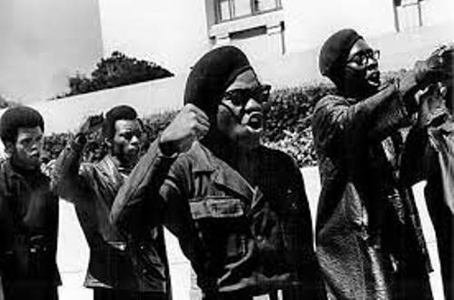
a) Klu Klux Klan
b) The Freedom Riders
c) Black Panthers
d) Double V

17. Who is depicted in the picture below?
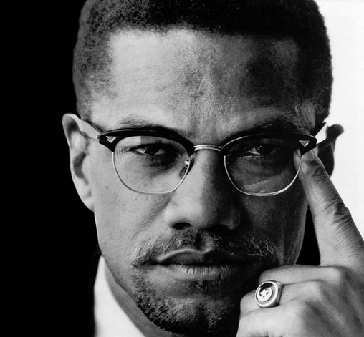

a) Martin Luther King Jr.
b) Malcom X
c) Rodney King
d) Fidel Lopez

Short answer
18. What were the differences between Martin Luther King Jr. and Malcom X?

19. How was baseball one of the first sports to break the color barrier? Explain?

Essay Question
Explain how segregation was separate but not equal.

